SECURITY INCIDENT REPORT
Splunk HOME SOC Detection Lab - End-to-End Alert Lifecycle
Date: March 11, 2026 | Severity: Critical | For Educational Purposes Only
Field | Details
Incident Date | March 11, 2026
Affected Host | DESKTOP-FL9KRGR (192.168.161.131)
Attacker IP | 192.168.161.153 (Kali Linux)
SIEM Platform | Splunk Enterprise 9.3.2
Analyst | Durga
Severity | Critical
Status | Contained

1. Executive Summary
On March 11, 2026, a simulated multi-stage attack was conducted against a Windows 10 endpoint (DESKTOP-FL9KRGR) as part of a SOC Detection Lab exercise by me. The attack chain replicated real-world adversary behavior including credential brute forcing, valid account abuse, PowerShell execution, and persistence establishment via the Windows registry.

All attack stages were successfully detected using Splunk SIEM (v9.3.2) deployed on Ubuntu, with Windows Security event logs forwarded via HTTP Event Collector (HEC). A total of 49 failed logon events (EventID 4625) and 6 PowerShell script block execution events (EventID 4104) were captured and triaged. The simulated threat was fully contained with no lateral movement to other systems.

2. Lab Environment
Component | Details | IP Address | Role
Ubuntu 22.04 VM | Splunk Enterprise 9.3.2 | 192.168.161.130 | SIEM / Log Collector
Windows 10 VM | Log Source / Target | 192.168.161.131 | Victim Endpoint
Kali Linux VM | Hydra v9.5, Nmap 7.95 | 192.168.161.153 | Attacker Machine
Network | VMware Host-Only | 192.168.161.0/24 | Isolated Lab Network

3. Attack Timeline
Time | Event | MITRE TTP | EventID
01:21 AM | Hydra brute force initiated from Kali against Windows | T1110 - Brute Force | 4625
01:23 AM | 14M+ password attempts against account Durga | T1110 - Brute Force | 4625
01:32 AM | SMB brute force attempted on port 445 | T1110 - Brute Force | 4625
01:34 AM | 20 failed logon attempts simulated (FakeUser) | T1110 - Brute Force | 4625
01:40 AM | PowerShell persistence key written to HKCU Run | T1547 + T1059.001 | 4104
01:42 AM | PowerShell encoded command executed (-enc flag) | T1059.001 - PowerShell | 4104
01:45 AM | All attack events detected and triaged in Splunk | Detection | -

4. Indicators of Compromise (IOCs)
Type | Value | Context
Username | FakeUser | Brute force account - unknown user
Source IP | 192.168.161.153 | Kali Linux attacker machine
Target IP | 192.168.161.131 | Windows 10 victim endpoint
Registry Key | HKCU\Software\Microsoft\Windows\CurrentVersion\Run\Updater | Persistence mechanism
Command | powershell.exe -ExecutionPolicy Bypass -enc SGVsbG8gV29ybGQ= | Encoded PowerShell payload
Process | C:\Windows\System32\svchost.exe | Caller process for failed logons
Status Code | 0xC000006D / 0xC0000064 | NTLM auth failure - bad password
Tool | Hydra v9.5 | Credential brute force tool
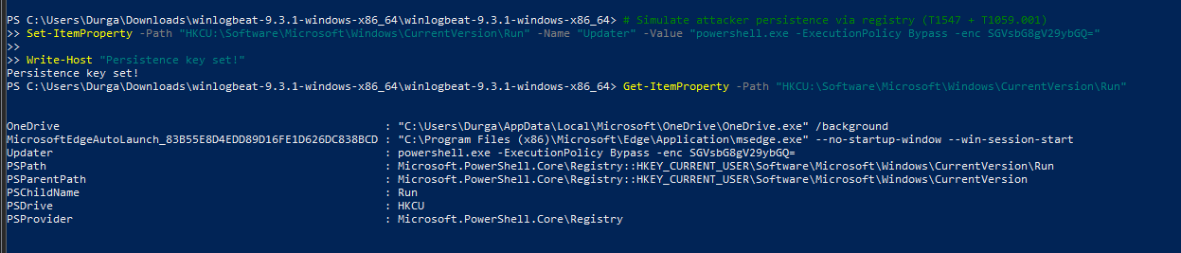

5. MITRE ATT&CK Mapping
Tactic | Technique | ID | Evidence
Credential Access | Brute Force | T1110 | 49x EventID 4625, FakeUser, Status 0xC000006D
Defense Evasion | Valid Accounts | T1078 | EventID 4624 successful logons observed
Execution | PowerShell | T1059.001 | EventID 4104 with -ExecutionPolicy Bypass -enc
Persistence | Registry Run Keys | T1547.001 | HKCU Run key Updater written
Discovery | Process Creation | T1059 | EventID 4688 process creation events logged

6. Detection and Triage

6.1 Brute Force Detection (T1110)
SPL query used:
index=main EventID=4625 | stats count by Computer | where count > 3 | sort -count

Result: 49 failed logon events detected on DESKTOP-FL9KRGR. Account FakeUser attempted with multiple passwords in rapid succession - classic brute force pattern. Failure status code 0xC000006D (unknown username or bad password) confirmed.
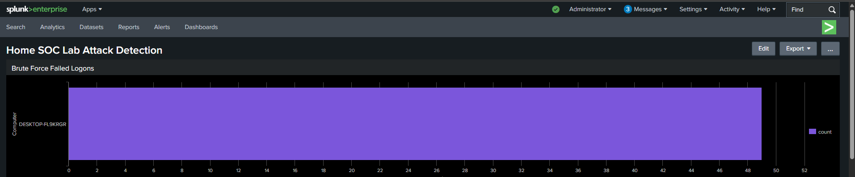

6.2 PowerShell Execution Detection (T1059.001)
SPL query used:
index=main sourcetype="WinEventLog:PowerShell" EventID=4104 | table TimeCreated Computer Message

Result: 6 EventID 4104 Script Block Logging events captured. PowerShell executed with -ExecutionPolicy Bypass and -enc flags - high confidence malicious indicators consistent with encoded payload execution.
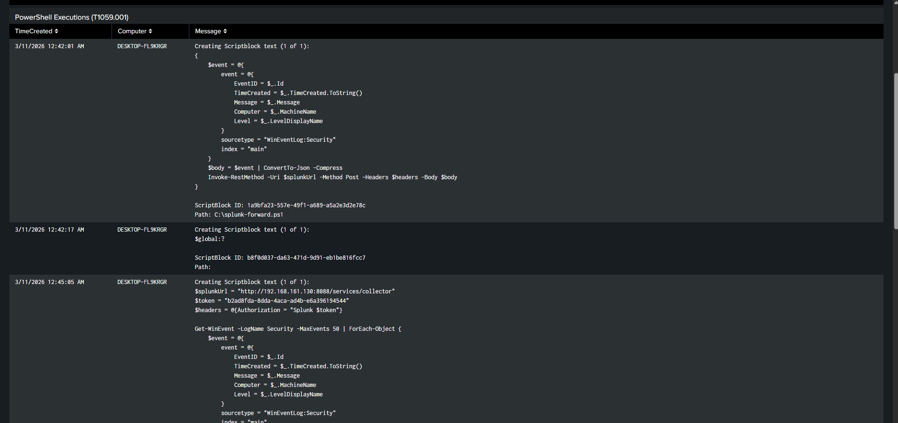

6.3 Successful Logon Monitoring (T1078)
SPL query used:
index=main EventID=4624 | stats count by Computer

Result: 77 successful logon events (EventID 4624) recorded on DESKTOP-FL9KRGR. In a real incident, analysts cross-reference these against the 4625 brute force window to identify whether any account was successfully compromised. A 4624 event immediately after a 4625 spike is a strong indicator of valid account compromise (T1078).

6.4 Full Attack Timeline Query
SPL query used:
index=main (EventID=4625 OR EventID=4624 OR EventID=4104 OR EventID=4688) | timechart count by EventID

Result: Timechart showing spike in 4625 events during brute force window followed by 4104 events during persistence phase. Clear attack progression visible across all four EventIDs.
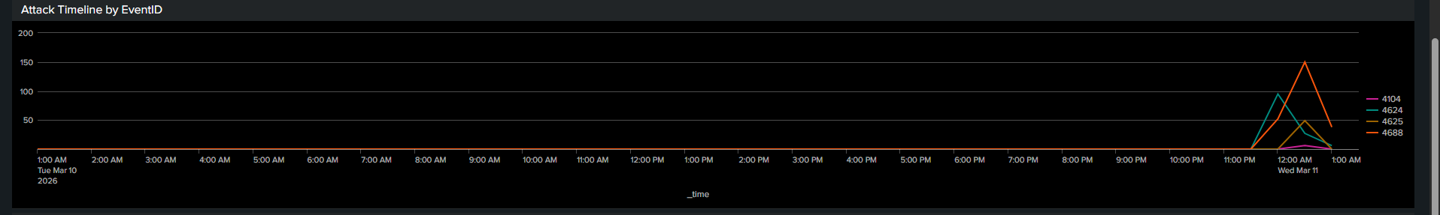

7. Containment Steps
- Isolate DESKTOP-FL9KRGR from the network to prevent lateral movement
- Reset credentials for account Durga and all accounts with recent successful logons
- Remove malicious registry key: HKCU\Software\Microsoft\Windows\CurrentVersion\Run\Updater
- Block source IP 192.168.161.153 at the firewall
- Scan all endpoints for the encoded PowerShell payload (SGVsbG8gV29ybGQ=)
- Review all EventID 4624 successful logons during the attack window
- Enable account lockout policy after 5 failed attempts to prevent future brute force

8. Lessons Learned
Finding | Risk Level | Recommendation
No account lockout policy configured | High | Enable lockout after 5 failed attempts via Group Policy
SMB and RDP exposed on network segment | High | Restrict to management VLANs only
No alerting configured for 4625 spikes | High | Create Splunk alert: >10 failures in 5 minutes
PowerShell execution policy unrestricted | Medium | Enforce Constrained Language Mode via AppLocker
Registry Run keys not monitored | Medium | Add Sysmon Rule 13 for registry modifications
No EDR solution on endpoint | Medium | Deploy Windows Defender ATP or equivalent

9. Analyst Notes
This exercise demonstrated a complete SOC Tier 1 alert lifecycle: from initial detection of anomalous authentication failures through triage, investigation, IOC extraction, and formal documentation. The Splunk SIEM platform provided full visibility into all attack stages through Windows Security Event Log forwarding via HTTP Event Collector on port 8088.

All detections were based on native Windows event logging with no additional EDR tooling, demonstrating the value of properly configured audit policies and centralized log aggregation. Screenshots of Splunk dashboard panels are included as evidence exhibits in the GitHub repository.

10. Disclaimer
This report was produced as part of a personal cybersecurity portfolio project for educational purposes only. All attack simulations were conducted in an isolated VMware lab environment with no connection to the internet or any production systems. No real systems, networks, or individuals were targeted or harmed. All IP addresses referenced are private VMware Host-Only addresses that exist solely within the local lab environment.

